|  |  |  |
| --- | --- | --- |
|  | Information Sciences and Technology Department |  |

**NSSA-220 Task Automation Using Interpretive Languages**

**Lab 1:** Linux Commands

# Instructions

Complete the tasks in Activity 1 and provide screenshots of the terminal that includes your commands and relevant output to prove that you were able to perform each task. The lab should be completed and submitted on an individual basis, but feel free to work with other classmates and ask for help from your instructor and TA as needed. When complete, submit the lab to the Lab 1 dropbox. The exact due date will be posted on myCourses.

# Preparation

* Read through this document
* Have your Linux notes handy

# Activity Summary

**Activity 0** – Modify your shell prompt

**Activity 1** – Linux commands

# Activities

## **Activity 0** – Modify your shell prompt

Before you begin working on the lab, you need to modify the prompt in your shell (terminal) to reflect your username, rather than the generic prompt of “student@localhost”. To modify your shell prompt, open a Terminal and type “nano .bashrc”. We’re now going to edit a file that executes every time you start up a terminal in your current session.

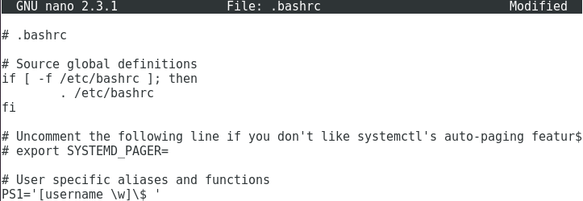

Add a line to the end of the file similar to the one above, except that you should use your RIT username in place of the word “username”. Save the file and exit nano. Then type exit to leave the Terminal. Open another Terminal and your prompt should now look like the following:



We will be looking for the correct username in your screen shots when the lab is graded, so make sure you follow these steps before working on any lab.

## **Activity 1** – Linux Commands

Perform the following tasks. For each task, include a screenshot that clearly indicates the command(s) that you used to accomplish the specified task as well as the output that proves that the task was accomplished correctly. Make sure that *your* username is in the screenshot prompt. If you’re unable to perform the task as specified, you may receive partial credit by providing the commands and output you were able to get and explain where you had difficulty. Any text you write should be written in red font.

**Task 1 (10 points): Write a single command that outputs a list of all programs in /usr/bin that begin with “ip”, begin with “net”, or end with “grep”. Hint: when using a $ in a regex, the $ comes *after* the string you want to match at the end of line.**

**Task 2 (20 points): Output a list of all subdirectories of /etc that you *cannot* open. The list should only include the full path of the subdirectories without any extraneous visible characters, such as “:”. See the output below for the first few subdirectories and expected formatting. This task must be accomplished in two commands or fewer. Hint: save the list of subdirectories to a file and then use filters.**

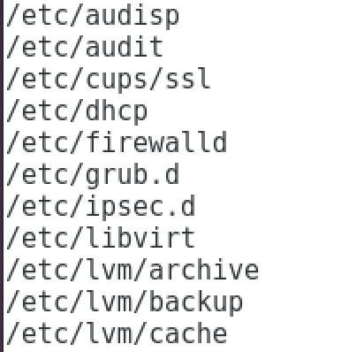



**Task 3 (50 points): Ted Williams was a baseball player that played Major League Baseball for 19 seasons between the years 1939 and 1960 and is considered The Greatest Hitter That Ever Lived™. Some of his statistics are stored in TeddyBallgame.csv on myCourses. You will be performing several tasks using this file. See the top line of the file for the definition of each field in the file. Note that since this is a .csv file, all fields are separated by commas.**

**Task 3a (5 points): Write a single command that removes the top line of the file, replaces commas with spaces, and saves the output to a file called TeddyBallgame.txt. Also show the contents of TeddyBallgame.txt in your screenshot (you should use a separate command to display the output to the console).**

**Task 3b (15 points): Use TeddyBallgame.txt from Task 3a as a starting point for this task. Write a single command to output the list of all seasons where Ted Williams had 100 or more Runs Batted In. Your output should only include the year and the number of Runs Batted In during that year.**

**Task 3c (15 points): Use TeddyBallgame.txt from Task 3a as a starting point for this task. Write a single command to output the list of all seasons where Ted Williams hit 30 or more Home Runs. The list should be sorted from most Home Runs to least and the final output should include the fields Year, Home Runs, Runs Batted In, and Batting Average for those seasons. See expected output below.**

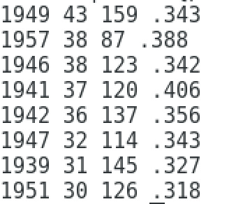

**Task 3d (15 points): Use the output of Task 3c as a starting point for this task either as a redirected output file or add more pipes to the command from Task 3c. Write a single command to sort the seasons from Task 3c by Runs Batted In from low to high. See expected output below.**

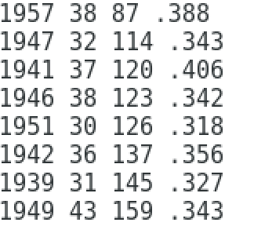

**Task 4 (20 points): Write a single command that stores (in a file called out.txt) the names of all .conf files located in /etc that contain an IP address beginning with “192.168”. Show the contents of out.txt in your screenshot using a separate command. See expected contents of out.txt below. It’s ok if your command generates error messages when it’s executed. To suppress error messages, you can redirect the error stream to /dev/null.**



